Journal of Nuclear Materials 122 & 123 (! 984) 91-95 **91**

North-Holland, Amsterdam

CONSTITUTIVE DESIGN EQUATIONS FOR THERMAL CREEP DEFORMATION OF HT-9

Robert J. AMODEO and Nasr M. GHONIEM

Fusion Engineering and Plasma Physics Program, University of California at Los Angeles, Los Angeles, California 90024, USA*

In this paper, we present the results of analysis of data provided by SANDVIK Steel Research Center for the high temperature properties of HT-9. We develop design equations for use in inelastic structural mechanics applications, for the most important thermal creep parameters. Empirical correlations for creep rupture time and the complete description of elongation vs. time are presented. A phenomenological description of steady-state creep is also developed. It is found that dislocation creep can explain the measured data.

1. *INTRODUCTION*

HT-9 is a ferromagnetic iron-base alloy that has been optimized to operate at high tempera­ tu res. It contains a relatively high chromium content, on the order of 12%, with additions of other alloying elements to achieve its design goal.

This alloy, developed by Sandvik Steel Com­ pany, has been proposed as a potential candi­ date alloy for fusion reactor applications 1 The primary reasons for this choice can be summarized as:

1. Ferritic and Martensitic steels exhibit great resistance to void swelling under neutron bombardment.
2. The thermal **stress** resistance is greater than austenitic alloys allowing the use of thicker sections for first wall applications.
3. Limited evidence indicates that helium gen­ eration by neutron irradiation does not significantly degrade the mechanical prop­ erties2.

In order to perform detailed structural ana­

lyses for fusion reactor blankets, designers must be provided with appropriate design equa­ tions. In this paper, we develop design equa-

tions for use in structural mechanics applica­ tions. Theoretically based creep equations may not be accurate enough to predict creep defor­ mation. We will therefore develop empirical equations that are accurate in a limited, yet im­ portant range. We will later develop a pheno­ menological description of the creep rates to ex­ plain the measured experimental data.

1. *DATA BASE*

We consider here two classes of creep data: the creep rupture life of tested specimens **as a** function of operating temperature and stress, and elongation as a function of time. This in­ formation is provided by the Sandvik Steel Company for temperatures of 500°C, 550°C, and 600°C, and stresses ranging from 12. 5 - 50 ksi. These data are the result of up to 5 years testing time of nine melts of HT-9. It consists of times to 1% strain, 5% strain and rupture, and elon­ gation to fracture for different stresses at each temperature. More details of the supplied creep test data are provided in reference (3).

1. *EMPIRICAL LAWS FOR CREEP DEFORMATION*
   1. *CREEP RUPTURE*

*Work is supported by the Department of Energy, Contract #DE-AM03-76SF00034 P.A.#DE-AT03- 82ERS2081 with the Office of Fusion Energy. The help of Dr. Thomas Anderson, Manager of the product development section of SANDVIK Steel Research Center is greatly appreciated.

0022-3115/84/$03.00 © Elsevier Science Publishers B.V. (North-Holland Physics Publishing Division)

92 *R.J. Amodeo, N.M. Ghoniem I Thermal creep deformation of HT-9*

Creep rupture data have been studied exten­ sively, with the objective of extrapolating the data to design Iives on the order of 30-40 yea rs. In a review of available methods, Le May" considered five different functional forms for creep rupture data. There is, however, no universally acceptable "standard" method.

*3 .1 .1. Minimum Commitment Method:*

As a result, the Minimum Commitment Meth­ od, a general formulation', was developed in 1971 for NASA to avoid forcing data th rough a set pattern. The equation based on th is method has the following form:



sight into the nature of material creep behav­ ior. It is therefore important to preserve the overall shape of this curve for design purpos­ es. The elongation versus time curve consists of the three following regions: (1) primary transient regime, (2) secondary linear regime,

(3) tertiary regime extending to creep rupture.

*3. 2. 1. Elongation for Three Creep Regimes:*

It is found that over most of the temperature range, the 1% strain falls in the primary region or at the beginning of the secondary region. The 5% strain is on the borderline of the secon­ dary-tertiary boundary, or well into the terti­

ary region. Extrapolating to O. 9*t5, where t 5 =

time to 5% strain, provides a point in the sec­ ondary region. Coupled with the 1% strain

where tr = rupture time, and ar

stress.

*3 .1.2. Modified Commitment Method:*

rupture

point, this yields the following form for the

primary-secondary region:

Ghoniem' has developed a general design equation which is a modified form of the Mini-

E(t) = [1 - exp(bt0) ]•100 %

(5)

mum Commitment Method. the following form:

This equation has

The constants b and *a* are fit in the following

manner: Let t1 = time to 190 strain, and El

0.01. Then

lnor

K(T) - _l_ lnt

m(T) r

(2)

*2*

K(T) *l* a T1

## i=O 1

*2* .

m(T) = *l* b/T1

## i=O

(3)

# (4)



a ln5/t *2*

5

E2 = 0.01 exp(at' *2* )

(6)

(7)

## (8)

Tis in °K, tr is in hrs., and *ar* is in ksi.

The data for HT-9 were fit to the above rela­ tion using a least-squares method. The coeffi­ cients ai and bi are provided in Table (1).

Table (1)

Coefficients for Rupture Time vs. Stress

a0= 138.4149302 b0= -1531.358687

a1= -0.3233496513 b1= 2506695.289 a2= l.946588668E-4 b2= -1017186681

* 1. *CREEP DESIGN EQUATIONS*

A plot of elongation versus time provides in-



 ( 10)

Here a, *a* > 0 and b < 0. This fit is good for

0 < t < 0 . 9*t 5 .

In the region between 0.9*t5 and t5 , the fit is determined by equations (6-8), with the

expression:

( 11)

*R.J. Amodeo, N.M. Ghoniem* / *Thermal creep deformation of HT-9* 93

## Finally, in the tertiary-rupture region, the fit is an exponential of the following form:

t *= l*

2*l* a j t i

## (17)

5 i=O *j=O*

2

**r**

# 1..4,T·

(12)

## with coefficients a .. found in Table (3).

IJ

 Table (3)

Coefficients for *t5* vs. Rupture Time

 a00 = 5.800300737E4 a12 = -4.906002324E-6

a01 = -142.9532355 a20 = 1.275428065E-3

## and E"R *=* elongation to fracture. This **is** good

for t5 < **t** < tr .

*3.2.2. Rupture Time Dependence:*

## It is necessary to fit these characteristic points to a reliable parameter, such as the time to rupture discussed in section (3. 1.2). Equa­ tion (2) can be re-written in the following form:

a02 = 8.746716625E-2 a -2.979495964E-6 a10 = -2.257160655 a22 = l.745094673E-9 a11 = 7.669299551E-3

## Finally, the elongation to fracture €R is found to rough,ly fit the rupture time in the, following functional form:

21

ln£R *=* n(T)•lntr + p(T) (18)

t *=* exp( m(T)•K(T)) *fa* m(t)

(13) 2 1

## r

1

where *a* is now the applied stress.

n(T) *= l* n T

i=O

2 i

(19)

## The time to 1% strain, t1, is found to be

best fit to the rupture time by the following form:

p(T) :: *l* p.T (20)

i=O I.

## The coefficients ni,. and pi are in Table (4).

lnt1 = J(T)•lntr + L(T)

2 •

J(T) : *l* Ji Tl

i-=O

2 •

L(T) *-= l* Li T1

*i=O*

(14)

(15)

(16)

## Table (4)

Coefficients for Elongation vs, Rupture Time

no"' 54.32308035 po= -465.7071298

n1= -0.1286025719 p1= 1.110624330 n2= 7.581206028E-5 p2= -6.547203129£-4

## and the coefficients Li , and Ji are listed in Table (2).

Table (2)

foefficients for t1 Yih Rupture Time

*3.2.3. Accuracy and Range af Applicability:*

## For the creep rupture curves, errors on a log scale for calculating the rupture time versus stress may translate into substantial errors (Figure (1)). Therefore, a given stress level

J0= -119.4828446

J1= 0.2860065163 J2= -l.687029056E-4

10= 1707.558058

11 -4.091847968

12= 2,435742087E-3

can only provide a fair but reasonable estimate of the time to rupture, based on the nature of the data. This amounts to about 20%-30% error in rupture times for the given stress and temp­

The time to 5% strain is fit to a pofynomial

function of both temperature and rupture time:

eratures.

There is considerable error in the functional determination of times to 1% and 5% strain, as

94 *R.J. Amodeo, N.M. Ghoniem I Thermal creep deformation ofHT-9*

much as 50%, but the data spread is so wide for these two particular times as a function of stress that such a deviation can be expected. These characteristic times also depend on the accuracy of the determination of rupture time.

In spite of these differences, the primary and secondary regions were fit with reasonable accuracy to the data, as can be seen in Figure

(2). The tertiary and rupture regions are

generally underestimated. As seen in Figure

In general it can be concluded, however, that the overall form of the creep strain curve is preserved with a certain degree of accuracy. The range of applicibilty is defined by the temperature limits 500°C - 600°C. The upper and lower limits of the stress in ksi versus

temperture in OK are given by:

*0* T 202.63 ksi.

u *=* - - + (21)

5

(2), this can amount to an error of about

20°0-3090.

o-l

- T + 189.63 ksl

5

-

(22)

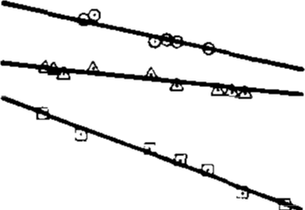

0 soo0c **DATA** *lo* sso0c **DATA** Gl eoo0c **DATA**

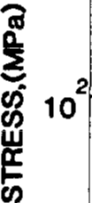

**10**

**3**

-DATA CURVE FIT

**10** '----'-------'----' '

**4**

**102 103 10 105 106**

**RPT. TIME, (hrs.)**

# FIGURE 1

HT-9 rupture stress vs. rupture time

*'I. PHENOMENOLOGICAL MODEL*

The dependence of the steady state creep rate on applied stress and temperature can be analyzed using an Ashby-type deformation map6• In particular, it is found that for HT-9 the phenomenon of dislocation creep is charac­ teristic of the data supplied by Sandvik Labora­ tories. Steady state dislocation creep involves the climb and glide of dislocations by means of stress-assisted vacancy movement, and is de­ scribed by phenomenological expressions such as7

c: Ao-n exp(-Q /RT)

C

(23)

where Qc

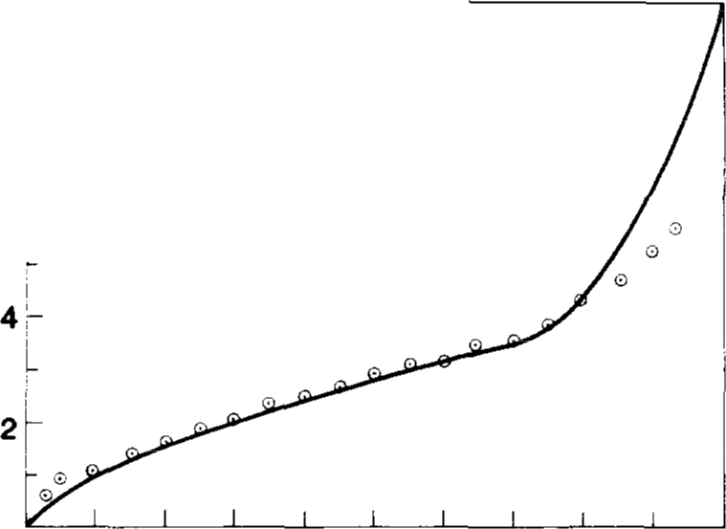

**10**

**8**

0 **SANDVIK DATA FOR HT-9**

**0**

.....

**z**

- **DATA CURVE** FIT

er

i

I

<<,

**0**

**z**

.J

w

fusion.

is the activation energy for self-dif­

It is found that for most pure metals n is usually in the range of 4-6, but in dispersion hardened alloys, the value of n has been found to be significantly higher'.

To explain this anomalous behavior, it has been suggested' that the creep takes place un­ der the influence of an active or effective

stress *a* - *a* , where *a* is the applied stress

*0*

### 0 2000 4000 6000 8000 10000

**TIME,(hrs)**

# FIGURE 2

Elongation vs. time for test temperature 600°C and stress level 15.2 ksi

and *a0* is the friction stress which the disloca­ tion must overcome to move through the lattice.

The dependence of creep rate on temperature and stress can be represented by the following

*R.J. Amodeo. NM. Ghoniem I Thermal creep deformation of HT-9* 95

form" due to the process of dislocation creep:

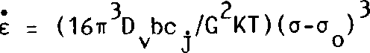 (24)

where

c = steady-state creep rate, c. = concentration of

J

jogs, o , = Av/b, v = velocity of mobile dislo-

0

cations, and A = tempera tu re dependent time constant. For HT-9, it is found that the above expression can be written using least squares:

The representation of creep strain determined in this report can be described by the following equation:



The coefficients for the correlations should be carried out to as many digits as possible for in­ creased accuracy. The equations should not be

E B (o-o )3 exp(-Q*/KT)

KT 0

(25)

used outside the range of applicability.

The HT-9 creep data in the range 500-600°C

where B 7.385 x 10·1 Q* = 1.23 eV, aT • C, a =-0.2185, and C = 198.178.

in °K, o and o , are in ksi.

0

o0 =

T is

is found to represent behavior typically de­ scribed by dislocation creep. The phenomenolo­ gical equation used to represent the data is

The value of Q* is close to the migration en­ ergy of vacancies, 1.2 - 1.3 eV, which may suggest that the dislocation creep mechanism in HT-9 is controlled by vacancy movement. This phenomenological formulation is good for the temperature range of 500°C - 600°C and stress levels limited by equations (21,22).

1. *SUMMARY AND CONCLUSIONS*

In this paper, we have developed useful de­ sign correlations for a number of commercial heats of HT-9. The design equations cover the following properties:

* 1. Rupture time as a function of applied stress and temperature, using a modifica­

tion of the minimum comittment method.

based on an effective stress acting on disloca­ tions. The friction stress was found to be only a function of temperature. This approach indi­ cates that dislocation climb is controlled by va­ cancy absorption at dislocations.

*REFERENCES*

1. N.M. Ghoniem, and R.W. Conn, Assess­ ment of Ferritic Steels for Steady-State Fusion Reactors, in: International Atomic Energy Agency *Proc. on Fusion Reactor Design and Technology,* IAEA-TC-392/62:Vol 11, p. 389, 1983.
2. R.L. Klueh, J.M. Vitek, and M.L. Gross­ beck, *Journal of Nuclear Materials* 103 & 104, (1981) 887
3. R.J. Amodeo, and N.M. Ghoniem, Consti­ tutive Design Equations for Creep Defor­
   1. Time to 590

strain as a function of stress

mation of HT-9, UCLA Report, to be pub­ lished.

and temperature.

* 1. Time to 1% strain as a function of stress and temperature.
  2. Rupture strain as a function of stress and

temperature.

* 1. Creep strain, as a function of time, temp­ erature, and stress. This covers the pri­ mary, secondary and tertiary regimes of creep.

1. I. LeMay, Principles of Mechanical Metal­ lurgy, (Elsevier, New York, 1982)
2. S.S. Manson, and C.R. Ensign, *NASA TM.X-52999* (1971).
3. M.F. Ashby, Acta. Met., 20, (1972) 887.
4. J.D. Parker, and B. Wilshire, *Metal Sci­ ence ,* (1975) 248.
5. B.A. Wilcox, and A.H. Claver, *Trans. Met. Soc. AIME,* 236 (1966) 570.